

**DINING ETIQUETTE**

If you are invited to interview during a meal, you want to feel comfortable and make a good first impression. The rules of dining etiquette are fairly straightforward and mostly require common sense.

**Using your napkin**

As soon as you are seated, place your napkin in your lap. Sometimes, at very formal restaurants, the waiter may do this for you. Let the napkin do its job – catch food that drops in your lap or dab crumbs from your lips. It should not be shaken out, crumpled up, or used as a hankerchief. When finished, fold your napkin and place it next to your plate.

## Ordering

Skim the menu quickly. Choose a medium-priced item. If you have difficulty deciding, follow your host’s lead or ask, “What do you recommend?” Do not discuss dietary restrictions or preferences. Select an item that is easy to eat (no bones or sauces with “splash” factor). Under age 21, do not order alcohol. Age 21+, the decision is yours. We suggest choosing a safe beverage such as soda, juice, or water. At all times, be respectful and thoughtful toward the restaurant staff.

## Participating in conversation

Go prepared to contribute to the conversation and make an effort to speak with everyone at the table. This is an opportunity for the employer to get to know you in a more social yet professional setting. Focus in on the conversation at hand, despite surrounding distractions. Relax as much as you can, but do not let your guard down, even if the conversation becomes casual. This is still an interview. Avoid controversial subjects. It’s helpful to be aware of the news of the day to be able to contribute to conversation.

**Handling the table setting**

It can be very confusing to be presented with a variety of eating utensils. The formal table setting is your worst case scenario! (Thankfully, most table settings are much less complex.) In all cases, “work from the outside in."

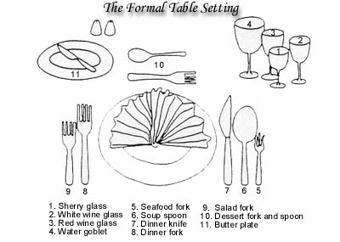

## Being served

Wait for everyone at your table to be served before beginning to eat, unless you are encouraged to begin. Eat slowly while waiting for their food to be served. When all are served, make every attempt to eat at the same pace as your host.

**Using utensils**

Cut one bite at a time then rest your knife. Between bites, your utensils should rest on the edge of your plate. Your knife rests on the back of your plate, your fork on the side of your plate. When you are finished, they rest together horizontally across the center of your plate, blade facing toward you.

## Eating & talking at the same time

The main point of the meal is to interact; eating is secondary. Take very small bites so you can eat and answer questions. Never speak with food in your mouth.

**Finishing up**

When finished with a course, leave your plate in its original location. Do not move your plates or stack them. Do not use a toothpick, even if one is offered. Thank the employer.

Though there are many things to keep in mind while dining, common sense should be your guide. If you are in doubt, watch your host and follow their cues.

*Updated 2010*